|  |  |  |
| --- | --- | --- |
|  | **Weekly Team Task Report** | **#11** |

|  |  |  |  |  |  |  |  |  |
| --- | --- | --- | --- | --- | --- | --- | --- | --- |
| Team: GeoLearn | | | | | | **Date: 4/7/2020** | | |
| **Project Title: Improving elementary education with custom online enironmental science lectures** | | | | | | | | |
|  | **Samuel Prassse**  Present  On-time |  | **Kaitlyn Grubb**  Present  On-time |  | **Tyler Pehringer**  Present  On-time | |  | **Joshus Tenakhongva**  Present  On-time |

### Recent Meetings:

* General Team Meeting
* Sponsor Meeting

### TASKS COMPLETED since last meeting:

|  |  |  |  |
| --- | --- | --- | --- |
| **Task Title: Continue website design** | **Task Initiation:** 3/9 | **Orig. Due Date: None** | **Status:** Completed but still under contruction |
| **Who (%): Tyler (100%)** | | | |
| **Description: Tyler will continue to develop the design of the website through meetings with Dr. Doughty and Roo.** | | | |
| **Expected Outcome: A sleek website that conforms to the sponsor’s specifications.** | | | |

### This week’s Tasks: Work plan for coming week

|  |  |  |  |
| --- | --- | --- | --- |
| **Task Title: Continue website design** | **Task Initiation:** 3/9 | **Orig. Due Date: None** | **Status:** In Progress |
| **Who (%): Tyler (100%)** | | | |
| **Description: Tyler will continue to develop the design of the website through meetings with Dr. Doughty and Roo.** | | | |
| **Expected Outcome: A sleek website that conforms to the sponsor’s specifications.** | | | |

|  |  |  |  |
| --- | --- | --- | --- |
| **Task Title: Database differences** | **Task Initiation:** 3/23 | **Orig. Due Date: 3/27** | **Status:** In Progress |
| **Who (%): Joshus (100%)** | | | |
| **Description: Joshus is looking into the differences that he finds between the Animaps database, and our database.** | | | |
| **Expected Outcome: Determine why their data is so different than the ones we currently have.** | | | |

|  |  |  |  |
| --- | --- | --- | --- |
| **Task Title: Get website up and running** | **Task Initiation:** 3/23 | **Orig. Due Date: 4/10** | **Status:** In Progress |
| **Who (%): Joshus (50%), Samuel (50%)** | | | |
| **Description: Joshus and Samuel are working on getting the Django app up and running on an Apache server on the EC2 instance. There have been several issues with a few different processes that we are hoping to resolve in today’s meeting.** | | | |
| **Expected Outcome: A fully functioning website prototype in beta build.** | | | |

|  |  |  |  |
| --- | --- | --- | --- |
| **Task Title: Dry run presentation** | **Task Initiation:** 4/6 | **Orig. Due Date: 4/10** | **Status:** In Progress |
| **Who (%): Team (100%)** | | | |
| **Description: The team is preparing slides and scripts to record a video for the dry run version of the presentation that is due Friday.** | | | |
| **Expected Outcome: A presentation covering the entire work year of capstone with the origina DR3 presentation mixed in.** | | | |

### Upcoming Tasks: Planning

|  |  |  |
| --- | --- | --- |
| **Task Title: Grading Presentations** | **Who (%): Team (100%)** | **Rough Due Date: 4/13** |
| **Description: Over the weekend, all teams will review and “grade” *three* other team presentations. I will provide a grading sheet for you as a template, and I’ll specify which teams each team reviews. This will help you see what others are doing…and help them improve it…which will help you gain insights to improve your own presentation. It’s a team exercise; I recommend teams assign everyone to watch the assigned videos, then get together on Zoom to collaborate on reviewing/grading them and writing up the review. DUE DATE: by Monday, at 5pm, you will email your reviews to (a) the team leads of the reviewed teams and (b) CC your team mentor. The team mentor will grade your reviews for completeness, thoughtfulness, quality of recommendations given.** | | |

|  |  |  |
| --- | --- | --- |
| **Task Title: Poster Due by COB** | **Who (%): Team (100%)** | **Rough Due Date: 4/19** |
| **Description: There is one more important change. As you know, every team has to prepare a poster and present that poster at Capstone. In the “virtual UGRADs” concept the organizers have come up with, UGRADs runs (virtually) for a *week* from 4/20-4/24…and they had wanted all posters and presentations by the 19th. We Capstone faculty pushed back saying you can’t deprive Capstone teams of a week, and got the 3/23 deadline through. But your POSTERS will be due by end of business on the 19th, so they can be part of the show and be viewed/judged in the poster competition. You will therefore want to be drafting your poster in the next few weeks as well, and reviewing it with your mentor. This is not a huge change from normal…just rules out last minute jobs on the poster.** | | |

|  |  |  |
| --- | --- | --- |
| **Task Title: Capstone Final Presentations** | **Who (%): Team (100%)** | **Rough Due Date: 4/23** |
| **Description: Capstone final presentations are due by end of business on Thursday April 23, the night before the regularly scheduled Capstone. The UGRADs folks promise there will be a way to upload them to the UGRAD site, which will be required.  We will also upload them with BBlearn, for easy collection and access by team mentors for grading.** | | |

### Other Problems / Other Issues:

* We can’t get the website up and running

**Github:**

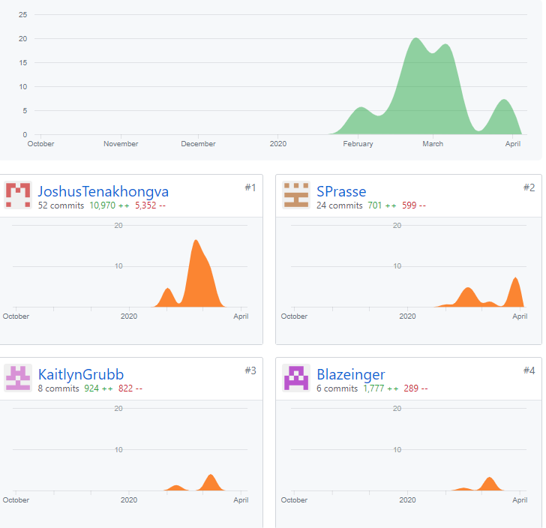

**Schedule:**

